CONSOLE INTERFACE USER'S GUIDE

Opis sprememb dokumenta

Datum | Izdaja | Opis sprememb | Avtor
28.06.05 | 0.01 | Začetni dokument | R.V.

1 INTRODUCTION
2 MAIN COnsole MENU

TABLE OF CONTENTS

1 INTRODUCTION 9
2 MAIN COnsole MENU 10
2.1 Change baud rate 11
2.2 BIN RT Download 11
2.3 Watchdog Reset 12
2.4 Goto BOOTLoader 13
2.5 LED Test 13
2.6 Normal operation 13
2.7 Config system 13
2.8 SHDSL Info 16
2.9 SW version info 16

Figures

Figure 1: Basic console printout 10
Figure 2: Main Menu options 10
Figure 3: RT unit download command 12
Figure 4: RT unit download to COT ok 12
Figure 5: Config sub menu options 14
Figure 6: Custom Config SHDSL1 14
Figure 7: Config ALL EMX systems 15
Figure 8: System info after config ALL EMX systems 15
Figure 9: SHDSL info 16
Figure 10: SW info 17

Tables

Table 1: Config EMX System 15

ABBREVIATIONS

SW – Software
HW – Hardware
FW – Firmware
COT – Centrale office Terminal
RT – Remote terminal
COM port – communication RS232 port on computer
EOC channel – embedded operations channel
RPFEED, RPF – Remote power feed of RT units from COT unit
CV – Code Violation
ES – Error Seconds
SES – Severe Error Seconds
VO – Voice only
V+E – Voice + Ethernet
TS – Timeslot ( 1TS = 64kb/s)
POTS – Plain Old Telephone Service
SHDSL - Single-pair high-speed digital subscriber line
BW - Bandwidth

INTRODUCTION
This document is describing usage of console interface on EMX family of devices from IPS company. There is short list of commands and description of how to use them. Console on EMX system is used on COT side only. Console can be used by supplied RS232 cable. If you did not receive RS232 cable please contact IPS at support@ips.si.

MAIN COnsole MENU
First install VT100 terminal program. Please set correct parameters for COM port. For EMX system correct parameters are:
- baud rate: 9600
- data: 8 bit
- parity: none
- stop: 1 bit
- flow control: none

Connect RS232 cable to COM port on computer.
When RS232 cable is applied to EMX COT unit (port marked with RS-232 on the front panel), there should be some printout on VT100 terminal.
Printout should look as follows:

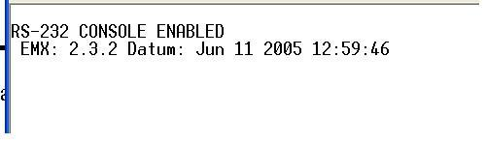
Figure 1: Basic console printout
Printout depends of version of Firmware installed on EMX device. Also when requiring support from IPS please provide this info. Next to EMX there is Firmware version (in this case 2.3.2). “Datum” means date of build for this version of EMX firmware.

To go into basic menu please press SPACE key. After SPACE key is pressed main menu options are displayed like seen on Figure 2: Main Menu options.

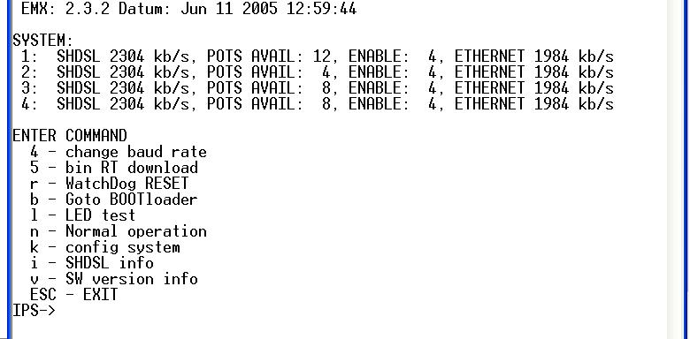
Figure 2: Main Menu options
Basic info about EMX system is presented.
Firmware version and date of build is in the first line. Then system information is presented. For example in Figure 2: Main Menu options 4x4 EMX system with Ethernet is configured. There is different RT units connected and available POTS shows which RT units are this. In our case on system1 is RT unit with 12 POTS channels and Ethernet on system2 is RT unit with 4 POTS channels and Ethernet, system 3 and 4 are identical 8 POTS channels and Ethernet, but enabled configuration is 4 POTS on each system and 1984 kb/s bandwidth for Ethernet.

Next list of available command is listed. This may vary depending on Firmware version.

Commands can be executed only after menu has been printed on VT100 terminal. If menu is not displayed press SPACE key few times. To start executing command press key listed next to menu option. To abort execution at any point »ESC« key can be pressed

Change baud rate
RS232 baud rate is changed by this command on EMX device.

Before executing this command menu should be displayed. If menu is not displayed press SPACE key few times.

This command is executed by pressing '4' on keyboard. After pressing '4' sub options are displayed. To abort executing command press ESC key. 9600 baud or 57600 baud can be selected by pressing '1' or '5' on keyboard. It is mandatory to change baud rate configuration of VT100 terminal after this command.

BIN RT Download
Remote preprogramming of RT unit is done by this command. Correct RT Firmware image should be obtained from IPS for this step.

Before executing this command menu should be displayed. If menu is not displayed press SPACE key few times. Press ESC key to abort execution at any time.

This command is executed by pressing '5' on keyboard. After pressing '5' RT unit must be selected as seen on Figure 3: RT unit download command. RT units are numbered as seen on front panel from 1 to 4. If 5 is pressed than all available RT units will be programmed. After according units are selected binary file should be sent to VT100 terminal.

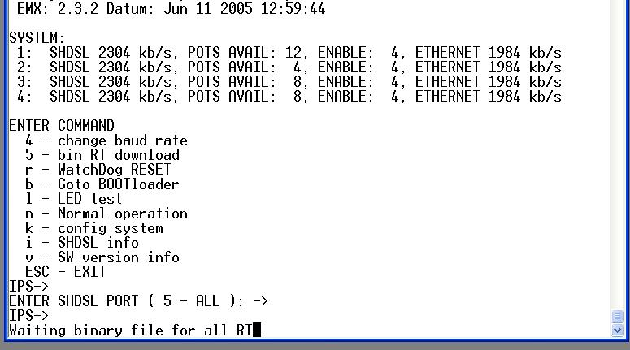
Figure 3: RT unit download command
After completion of transfer CRC will be checked on COT unit and displayed as RAM CRC OK! as seen on Figure 4: RT unit download to COT ok. Then transfer on EOC channel will be done for few minutes to all selected RT units (in our case four units). Also count of packets is displayed in VT100 terminal window. Usually count reaches number around 500 but number depends on version of firmware.

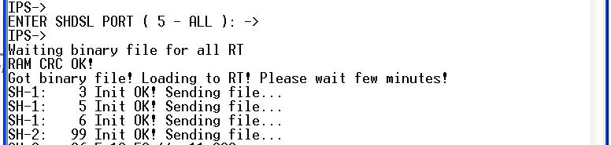
Figure 4: RT unit download to COT ok
After completion of transfer from COT to RT unit following lines should be displayed on VT100 Terminal window.
SH-1: 573
SH-1: File sent to RT!
SH-1 :Aplication uploaded OK!
This indicates that transfer is completed without problems. After this RT unit is reset and starts training again.

With version command can be checked if transfer is successful.

Watchdog Reset
This command performs hardware reset of EMX COT device and all remote powered RT units.

Before executing this command menu should be displayed. If menu is not displayed press SPACE key few times. Press ESC key to abort execution at any time.

Goto BOOTLoader
This command performs software reset of EMX COT device and all remote powered RT units.

Before executing this command menu should be displayed. If menu is not displayed press SPACE key few times. Press ESC key to abort execution at any time.

LED Test
This command is used to perform LED Test of all LEDs on EMX COT device. Blinking of all LEDs in all colors is performed. This function is executed until normal operation command is executed.

Before executing this command menu should be displayed. If menu is not displayed press SPACE key few times. Press ESC key to abort execution at any time.

Normal operation
This command is used to set EMX COT device into normal operation. This command cancels all test modes on EMX device.

Before executing this command menu should be displayed. If menu is not displayed press SPACE key few times. Press ESC key to abort execution at any time.

Config system
Эта команда используется, чтобы установить конфигурацию системы EMX. Есть некоторая предопределенная конфигурация, но возможна также и ручная конфигурация.
Перед выполнением этой команды меню должено быть отображено. Если меню не отображено, нажимают SPACE KEY несколько раз. Нажмите клавишу ESC, чтобы прервать выполнение в любое время.
Когда нажата клавиша “k” появляется меню со списком предопределённых конфигураций. Здесь же есть команды, чтобы сохранить и загрузить конфигурацию, установить НИЗКОЕ или ВЫСОКОЕ напряжение питания линии.
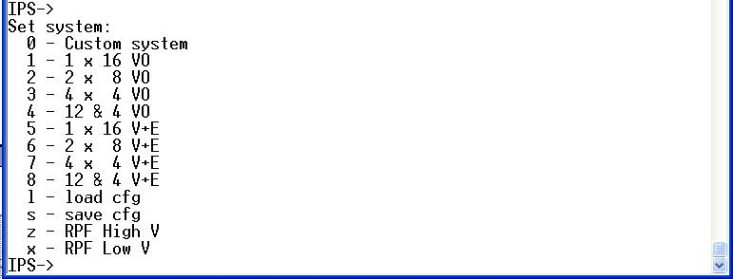
Figure 5: Config sub menu options
От '1' до '4' - варианты только для Голоса. От '5' до '8' – варианты Ethernet и Голос. Они - предопределенны системой. 'l' - для того, чтобы загрузить сохранённую конфигурацию. 's' для сохранения конфигурации. Это параметры настройки также применятся после того, как перезагружено устройство. 'z' должен установить всё дистанционное питание (далее ДП) в высокий уровень (300V в зависимости от типа т ДП), 'x' используется, чтобы установить всё ДП в низкий уровень (240V в зависимости от типаДП)

Командой "0" выводим меню ручной конфигурации. Есть две возможности. Сначала должен быть выбран канал SHDSL. Если выбран от 1 до 4 как на иллюстрации 6(пример): Допущена только конфигурация SHDSL1, она может быть изменена (это даёт возможность другим системам работать без прерывания).

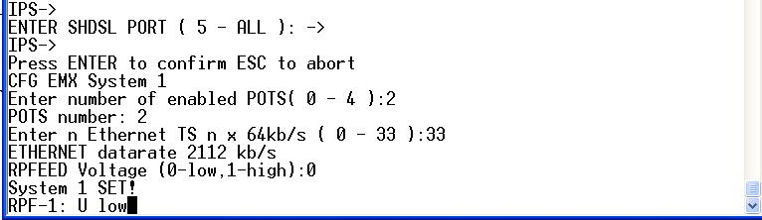
Figure 6: Custom Config SHDSL1

Сначала вводим количество активных голосовых портов. Вводиться число используемых телефонных портов. Даже если абонентский комплект имеет 16 портов, можно ввести любое число от 1 до 16, например 4. Эта опция обеспечивается, чтобы иметь большую пропускную способность Ethernet в случае, если все абонентские порты не используются в этом направлении. Следующий выбор - Ethernet timeslots. Введенное число тогда умножается на 64 килобайта в секунду, чтобы получить пропускную способность Ethernet. Максимальная пропускная способность - 2304 килобайта в секунду на линии SHDSL, и эта скорость делится между обычной телефонной сетью и Ethernet. Затем устанавливается напряжение ДП, низким или высоким.

Если изменения нужно сохранить: «пробел», «k», «s». Если этого не сделать, при перезагрузке все изменения будут потеряны.

Если нажать '5' в меню выбора канала SHDSL, все доступные ресурсы системы EMX могут быть изменены. Те же самые параметры могут быть конфигурированы как прежде, в единственном системном изменении. Все доступные системы должны быть конфигурированы здесь. Система от Таблицы 1(пример): Конфигурация Система EMX установлена как замечено на иллюстрации 7: Конфигурация ВСЕ системы EMX.

EMX System | POTS Number | Ethernet  TSx64 kb/s = BW | RPFEED  Level
1 | 2 | 33x64kb/s = 2112kb/s | Low Level
2 | 6 | 10x64kb/s = 640kb/s | High Level
3 | 4 | 31x64kb/s = 1984kb/s | Low Level
4 | 4 | 0x64kb/s = 0kb/s | Low Level
Table 1: Config EMX System

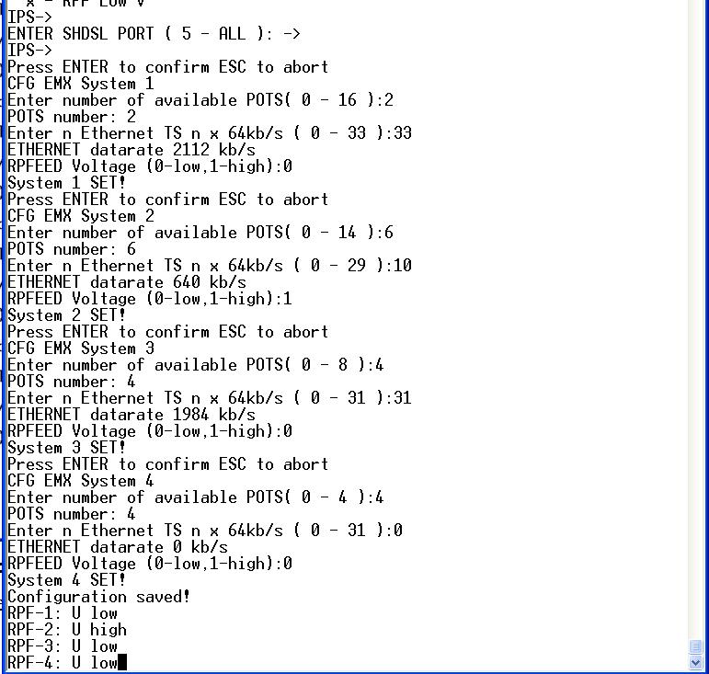
Figure 7: Config ALL EMX systems
Информация главного меню измениться как на иллюстрации 8: Системная информация после конфигурации ВСЕХ систем EMX после ручной конфигурации системы.

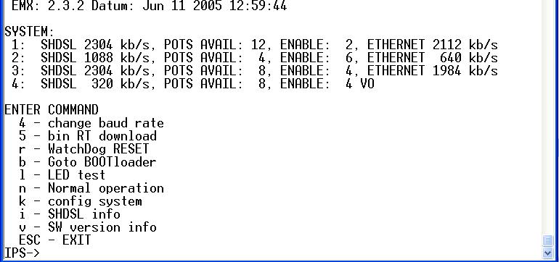
Figure 8: System info after config ALL EMX systems

SHDSL Info
This command is used to list SHDSL information of EMX system. Information for SHDSL from 1 to 4 can be obtained separately or for all active SHDSL channels by pressing 5.

Before executing this command menu should be displayed. If menu is not displayed press SPACE key few times. Press ESC key to abort execution at any time.

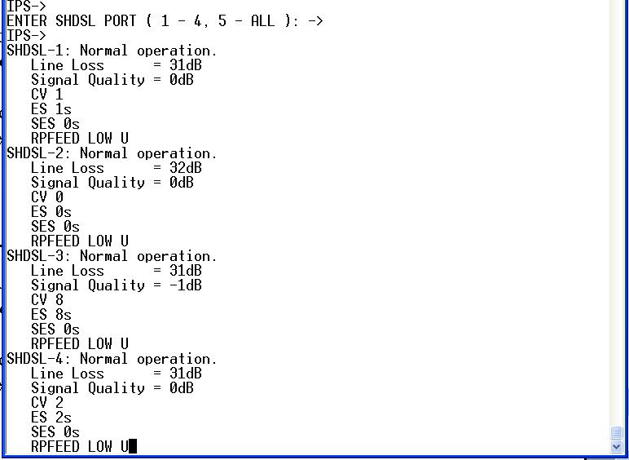
Figure 9: SHDSL info
Data presented is Line Loss in db, Signal Quality in dB, Code Violation (CV), Error Seconds (ES), Severe Error Seconds (SES) and RPFEED status (LOW, HIGH, OFF) as seen on Figure 9: SHDSL info

SW version info
This command is used to display versions of all software components in EMX system. It displays version info for COT device and also for all RT devices which has active SHDSL link. Data presented is Hardware version (HW), Serial Number (SERIAL), Firmware version of EMX device (EMX), firmware version of SHDSL device (SHDSL), firmware version of FPGA device (FPGA) as seen on Figure 10: SW info. This info should be provided to IPS if any support requirements are needed.

Before executing this command menu should be displayed. If menu is not displayed press SPACE key few times. Press ESC key to abort execution at any time.
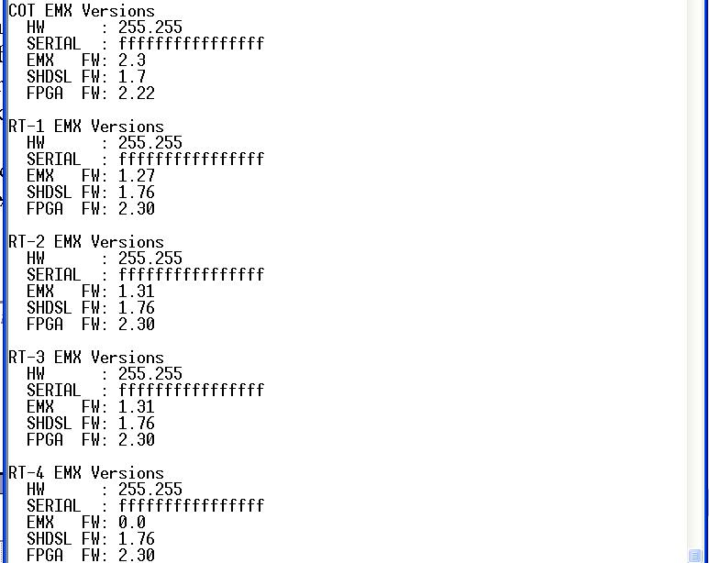

Figure 10: SW info

